V6Z80P + V1.1b

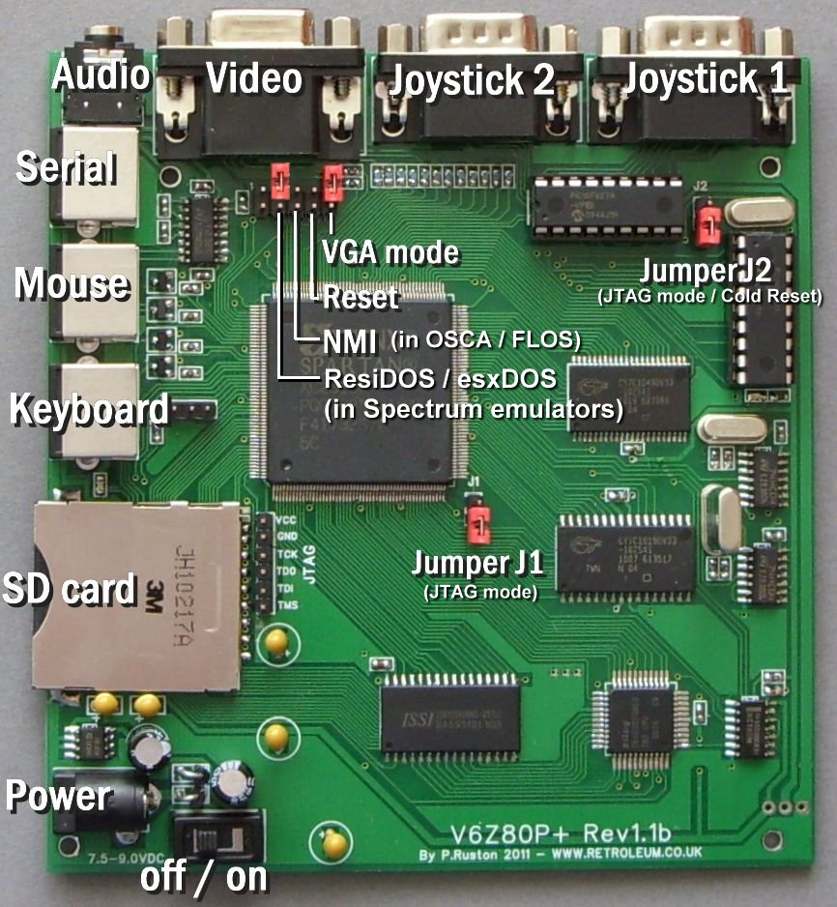

For the complete project archive / latest full documentation please visit:

wiki.retroleum.co.uk

Getting started - Basic Info

Basics:

The V6Z80P system - as supplied - comprises 3 main elements:

1. The PCB itself, this is the actual "V6Z80P”

2. My default FPGA architectural design for the FPGA called "OSCA" (Old School Computer Architecture) stored in the onboard EEPROM.

3. My command line operating system called "FLOS" (Freezer-Like Operating System) stored in the EEPROM and / or on SD card.

The V6Z80P requires a 7.5 volt (or 9 volt maximum) DC regulated mains adapter capable of delivering about 800mA or more. The jack plug should be 2.1mm type, centre-pin positive.
Before powering up:

Connect power, PS/2 keyboard, video/audio cables, make sure the VGA-mode jumper (on the 10 pin header) is installed if using a PC monitor. The JTAG jumpers (J1 and J2) should be uninstalled for normal EEPROM-based start-up.

Download the full project archive from wiki.retroleum.co.uk to PC then format an SD card to FAT16 (please use a good brand to ensure compatibility). Copy the contents of the folder "V6_SD_Card" from the project archive to the card and insert it into the V6Z80P's card slot. (You can use the V6Z80P without an SD card, but you'll need to download everything serially - except the internal commands - via serial comms).

Power on the V6Z80P with the switch near the DC power socket - the red LED should come on. On screen, the black and white boot-up display appears and afterwards, the OS loads (from SD card if present, or if not, from the onboard EEPROM). Once loaded, you can type "?" <return> for a list of internal commands (and “HELP (command_name)” for more detailed info.)

Programs can be run from the SD card (use the command line to navigate in a similar manner to DOS) or downloaded into memory via serial comms from a Windows PC using the serial_link cable and utility provided (see the "PC_based_apps" folder in project archive). Most of the demos etc can be quit by pressing the ESC key.

FPGA Configs:

As supplied, OSCA for 50Hz PAL TVs (or VGA monitors) is in EEPROM Slot 1, OSCA for 60Hz NTSC TVs (or VGA monitors) is in Slot 2. On power-up, the FPGA configures from whichever is the Power-on Boot Slot. This will be set at Slot 1 or Slot 2 depending on the location the board was dispatched to.

Cycle-perfect Spectrum Emulator: Alessandro Dorigatti’s Spectrum 48, 128 and Pentagon 128 emulators are in slots 3, 4 and 5 respectively. To use these configurations, enter the FLOS command “EMU” and follow the prompts. (The first time you run an emulator you will need to tell the program where (on the EEPROM) its config file resides - simply enter 3, 4 or 5 as appropriate) Full documentation for these emulators is provided in the folder “Alternative Configs/Alessandro” (Note: Using EMU does not change the power-on slot.)

General Notes:

For stability, avoid connecting or disconnecting anything to the V6Z80P whilst the power is switched on.

FLOS cannot automatically recognize card swaps so any card inserted whilst the power is on needs to be initialized with the "MOUNT" command.

If your PC doesn't have a (free) serial port, a USB->RS232 cable/adapter should work - please ensure you use its latest drivers.

Please read Documentation/Manuals/User_Manual.html for a fuller introduction to the V6Z80P - this can be found in the project archive and is also linked directly from wiki.retroleum.co.uk

